PUBLIC SPACE COMMITTEE MEETING DATES

Below is the notice for the regularly scheduled public meetings for
Calendar Year 2023:

HEARING DATES
January 26, 2023
February 23, 2023
March 23 2023
April 27, 2023
May 25, 2023
June 22, 2023
July 27, 2023
August 24, 2023
September 28, 2023
October 26, 2023
November 16, 2023
December 21, 2023

To confirm attendance and location, please contact the Public Space Committee at PublicSpace.Committee@dc.gov or
(202) 442-4960

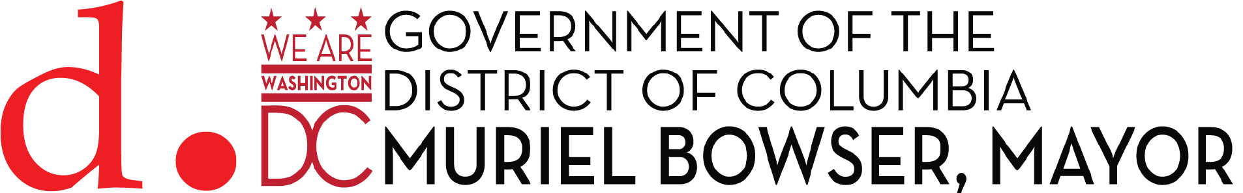
All applications must be submitted by 2 p.m. on the deadline date.

