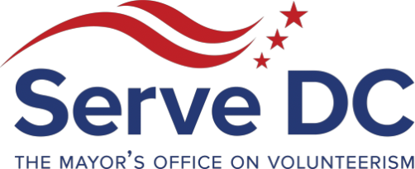

DC Commission on National and Community
Service 2000 14th Street NW | Suite 101 | Washington, DC 20009 10.9.2018 | 6:30 PM
SDC Quarterly Commission Meeting
Tues, October 9, 2018, 6:30-8:00 PM EDT
AGENDA

- Roll Call | Sareeta Spriggs
- Updates | Delano Hunter
- Serve DC Branding Refresh | Antoine Battle
- AmeriCorps Presentation | Earth Conservation Corps
- Overview of Active Shooter Response Training | Dr. Willie McElroy
- Review of Summer Youth Emergency Academy (SYEPA)| Michael Briscoe
- Update on Strategic Partnerships + Upcoming Seasons of Service | Isha Foster-Lee
- Ways to get involved | Sareeta Spriggs
- Commissioner Updates
- Adjournment

