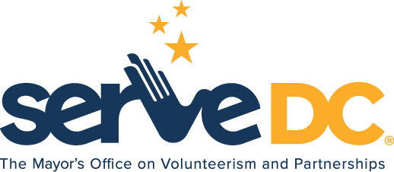

Commissioners Meeting Minutes
Wednesday, August 18, 2021 @ 6:00pm

Call to Order:
Chairman Andrews called the meeting to order at 6:04 p.m.

Roll Call: Commissioners Present

Brandon Andrews
Elana Son
Jason Anthony
Johnnie Rice
Carolina Celnik
David Horwitz
Kenia Colon-Torres

Review of Past Meeting Minutes:

A motion was made by commissioner to accept minutes. Minutes were accepted.

Director’s Updates:

- American Rescue Plan – Updates
- $620 million for AmeriCorps;
- $20 million for VGF; &
- $20 million for State Service Commissions

- Serve DC Award Updates: Competitive
- City Year $139,500 additional funds
- Literacy Lab $290,327 additional funds

- OIG Audit
- Personnel Updates

Finance & Operations

- CIF/PDAT round 2 funding
- American Rescue Plan
- HSEMA Funding
- Performance Evaluations

Program Updates

National Service

- SDC was awarded grant funding for 2021

Partnerships & Engagement

- Points of Light Scholarship
- Destination DC Community Cares Campaign
- Maternal & Infant Health Summit
- Serve 202 – Focus on Priority Challenges
- Beat the Streets and National Night Out

Donations
- GMAC Conference

Volunteerism & Service
- 9/11 Day of Service – 20th Anniversary
- New Volunteer Engagement Strategy
- Vaccination Requirement and Guidance

Emergency Preparedness
- Snow Team Data
- Events & Activations

Chair Andrews adjourned the meeting at 7:36 p.m.

Click the link below to view meeting:

https://web.microsoftstream.com/video/6b03f76f-0525-42ff-842e-43f03fef9d15

