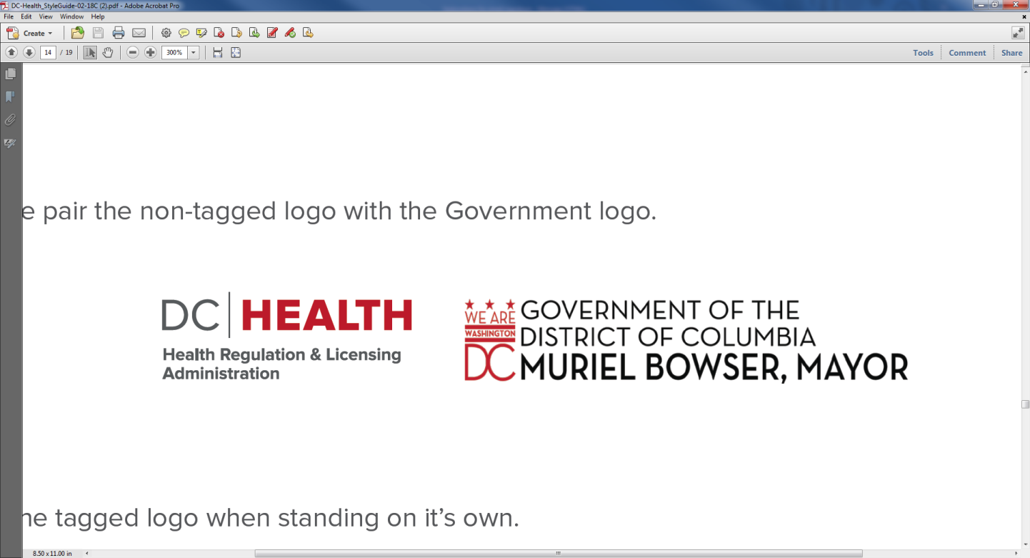

**899 North Capitol St. NE – 2nd Flr.**

**Washington, dc 20002**

**June 7, 2018**

**9:30am- 11:30 am**

**Open Session Agenda**

**Board of Pharmacy Mission Statement:**

“To protect and improve the public health through the efficient and effective regulation of the practice of Pharmacy and Pharmaceutical Detailing; through the licensure of Pharmacists, Pharmaceutical Detailers, Pharmacy Interns, and Pharmacy Technicians.”

**CALL TO ORDER**:

**PRESIDING**:

**BOARD MEMBERSHIP/ATTENDANCE**:

|  |  |  |
| --- | --- | --- |
| BOARD MEMBERS: |  |  |
|  | Dr .Daphne b. Bernard, Pharm.D. R.PH chairperson |  |
|  | Mr. James Appleby, R.PH vice chair |  |
|  | Dr. Benjamin Miles Pharm.D. R.PH |  |
|  | Mr. Alan Friedman, R.PH |  |
|  | Dr. Tamara mccants |  |
|  | chikita sanders, consumer Board member |  |
|  |  |  |
| STAFF: | Shauna White – Executive Director |  |
|  | Latasha Gaskin, Health Licensing Specialist |  |
|  | Lawrence Holland, Board Investigator |  |
|  | Luanne Greenaway, health licensing specialist |  |
|  |  |  |
|  |  |  |
| LEGAL STAFF: | Carla Williams, assistant general counsel |  |
|  |  |  |
|  |  |  |
| VISITORS: |  |  |
|  |  |  |
|  |  |  |
|  |  |  |
|  |  |  |
|  |  |  |
|  |  |  |
|  |  |  |
|  |  |  |
|  |  |  |
|  |  |  |
|  |  |  |
|  |  |  |
|  |  |  |
|  |  |  |
|  |  |  |
|  |  |  |
|  |  |  |
|  |  |  |
|  |  |  |
|  |  |  |
|  |  |  |
|  |  |  |
|  |  |  |

**Open Session Agenda**

**Quorum**:

|  |  |  |
| --- | --- | --- |
| **Introduction:** |  |  |
| **0607-O-01** | **Approval of the Open Session Meeting Minutes**  March 1, 2018  April 5, 2018  May 3, 2018 |  |
| **Consent Agenda** | **None** |  |
| **Executive Director Report** | **Licensing Report**  **Statistics**  **NABP Updates**  **Naloxone Training Update** |  |
| **Assistant General Counsel Report** | **None** | Carla Williams |
| **Subcommittee Report** |  |  |
| **0607-O-02** | **Legislative and Regulatory**  **Defending Access to Woman’s Health Care Services Amendment Act of 2017** | Alan Friedman |
| **0607-O-03** | **Communications Subcommittee Report** | Dr. Daphne Bernard |
| **Pharmacy Intern Presentation** | **Pharmacy News Update** | Katherine  Ahn |
| **NABP E-Newsletter** | **May 10, 2018 NABP E-News**  **NABP 2018-2019 Executive Committee Inaugurated at 114th Annual Meeting in Denver, CO**  **NABP Honors Leaders at the Forefront of Public Health Protection at Association’s 114th Annual Meeting**  **FDA CDER Report Provides Updates on Agency’s 2017 Drug Safety Initiatives and Priorities**  **May 5, 2018 NABP E-News**  **New NABP Report Examines Practice and Regulation of White Bagging and Brown Bagging**  **GAO Recommends US Agencies Develop Performance Metrics to Gauge Effectiveness of Efforts to Combat Synthetic Opioid Threat  AWARXE Program Supports CVS Health and Walgreens Drug Disposal Initiatives, New Locations Added  US Court Sentences Canadian Pharmacy Owner for Selling Counterfeit Prescription Drugs to Health Care Providers** |  |
| **Matters for Board Consideration** | **None** |  |
| **Public Comments** |  |  |
| **Motion to Adjourn the Open Session** | “Madam Chair, I move that the Board close the Open Public session portion of the meeting and move into the Closed Executive Session portion of the meeting pursuant to D.C. Official Code § 2-575(b) for the following purposes: to discuss disciplinary matters pursuant to § 2-575(b)(9); to seek the advice of counsel to the board, to preserve the attorney-client privilege, or to approve settlement agreements pursuant to § 2-575(b)(4); and to plan, discuss, or hear reports concerning ongoing or planned investigations pursuant to § 2-575(b)(14).”  (Roll Call Vote) |  |

This concludes the Public Open Session of the meeting. The Board will now move into the Closed Executive Session portion of the meeting pursuant to D.C. Official Code § 2-575(b) for the reasons set forth in the motion.

**Open Session Meeting Adjourned at __:__**