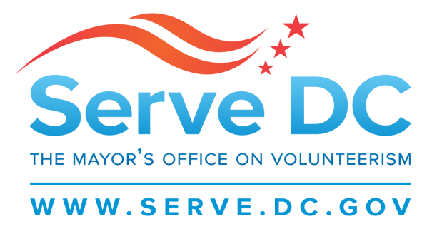

Commission Meeting Minutes

Monday, July 9, 2018; 6:30 PM

The meeting took place in Serve DC’s conference room and also online via GoToMeeting.

**Call to Order**: Brandon Andrews

**Roll Call**

Rochelle Howard

Charice Williams

Brandon Andrews

Edward Jones

Barbara Cline

Amy Cohen

Antoinette Mitchell

Nate Treffeisen

Lars Etzkorn

Joshua Johnson

**Reading of Past Meeting Minutes**

Pamela Weinberg mentioned that the April 2018 minutes can be found online at [www.serve.dc.gov](http://www.serve.dc.gov).

**Past Events**

Antoine Battle, Serve DC’s Director of Communication gave a short introduction of himself and proceeded to list the past events. Global Youth Service Day took place on April 21. Serve DC partnered with The Mission Continues at Kramer Middle School and over 200 residents were engaged. Serve DC also hosted a National Level Exercise at the Barry Farm Recreation Center and over 150 attendees from HSEMA, NCCC, and DDOT participated in the exercise.

**Upcoming Events**

Yerlina Santos, the Grants Management Specialist listed the upcoming events for this summer. The Mayor’s Office of African Affairs will be hosting the Mandela Day of Service on July 21from 1PM-3PM. For more information please contact the African Affairs Office at 202-727-5634 or visit Eventbrite to register for the event. Yerlina will share the flyer with commissioners to distribute to their networks.

My Brother’s Keeper Volunteer Recruitment Fair will take place on August 22 from 4:30PM-7:30PM at the Walter E. Convention Center. Serve DC requests Commissioners to assist with recruiting 13 more organizations to help us hit our target of 60. This is an opportunity for organizations to connect with skilled volunteers such as mentors and coaches.

Commissioner Edward Jones would like a list of previous organizations that have participated in the fair.

Antoine spoke briefly about the Community Emergency Response Trainings (CERT) that will be held this summer. The trainings will be held on July 10, 12, 24, 26 and 28 from 6PM-9PM). Interested individuals can register here <https://servedc.galaxydigital.com/need/detail/?need_id=341309>.

Commissioner Charice Roper Williams spoke of the great work that the SYEPA students are engaging in emergency preparedness.

**CNCS Transformation and Sustainability Plan**

Pamela covered the CNCS Transformation and Sustainability Plan. This plan is supposed to increase effectiveness and accountability. The goals are as follows-

**Goal 1**- Strengthen core business functions.

i.e- drilling down transactions and checking for accuracies when it comes to salaries through reviewing timesheets.

**Goal 2**- Strengthen and align grants management and monitoring to improve efficiencies and maximize effectiveness.

i.e- assigning one program manager to respond to all program questions.

**Goal 3**- Prioritize evidenced-based interventions.

i.e- maintaining flexibility when it comes to refining intervention models. Commissioner Gail Oliver requested to see the tool that CNCS uses for capacity building. Pamela will share the 7 page checklist with everyone.

**Goal 4**- Simplify and streamline the application process.

i.e- create a common application for all programs (NCCC, Senior Corps, Vista).

**Goal 5**- Simplify the CNCS brand.

i.e- increase public awareness.

**Goal 6**- Align workforces and workplaces to better serve customers, meet evolving needs and ensure efficient use of taxpayer dollars.

CNCS will be hosting Listening Sessions. One will be held in Los Angeles, CA on July 26. Boston, Massachusetts will hold a listening session on August 2 and there will be a virtual listening session on August 8. Written comments will be due on August 24.

**Jumpstart for Young Children Presentation**

Jumpstart’s mission is “Every child in America enters kindergarten prepared to succeed”. Jumpstart provides language, literacy, and social-emotional programming for preschool children from low-income neighborhoods.

Jumpstart has been serving in DC since 1998 with the George Washington University and is now serving in 7 of DC’s wards. Members work between 10-15 hours. The members follow Jumpstart’s model which starts with a Welcome/Reading/Circle Time/Let’s find out about it/Center Time/Sharing and Goodbye.

Commissioner Edward Jones inquired about Jumpstart’s community engagement model which Jumpstart is trying to improve. They’ve recently hired a Partnership Manager who will be responsible for mainly getting into the community.

**AmeriCorps Grants Update**

The following organizations were funded for the Competitive portfolio. They are:

* City Gate
* Jumpstart for Young Children
* Reading Partners
* The Literacy Lab
* Teach for America

In total, the competitive portfolio was awarded $3,052,976.00 and has a total of 548 members.

The following organizations were funded for the Formula portfolio. They are:

* After School All Stars
* Center for Inspired Teaching
* Latin American Youth Center
* Washington AIDS Partnership
* Earth Conservation Corps
* Teens Run DC
* Relay Graduate School
* Kid Power
* Higher Achievement

In total, the formula portfolio was awarded $654,592.00 and has a total of 134 members.

In addition to the Formula and Competitive portfolios, Serve DC also manages 3 planning grants for

The Youth Leadership Foundation, CASA DC, and the Neighborhood Association Corps in the amount of $93,662.00. The planning grants are meant to prepare organizations to apply for the AmeriCorps grant.

Meeting adjourned.