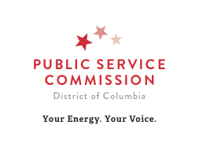

AGENDA
Commission Meeting – 2:00 pm Wednesday, January 6, 2021
A recording of the Open Meeting will be available on the Commission’s website after the meeting concludes

Disclaimer: The items reflected below are tentatively scheduled to appear on the Commission’s Meeting Agenda on the date indicated above. The Commission may add or delete items to the planned Agenda if it is deemed necessary.

Formal Case Matters for Action:

  - TT00-5 – Notice regarding Verizon Washington, DC Inc.’s ROW Compliance Filing for 2020.

- Announcements:

The next regular scheduled Commission meeting is January 13, 2021, 2:00 p.m.

  - Formal Case No. 1162 – WGL Rate Increase Application. The Commission will hold a Virtual Public Interest Hearing on January 27, 2021, at 11:00 a.m. to consider the Non-Unanimous Agreement of Stipulation and Full Settlement filed on December 8, 2020.

Adjournment:

Reasonable accommodations will be made at Public Service Commission proceedings for qualified persons with disabilities, if requested 2 days in advance of the proceeding, (Dial 202-626-5150). For weather-related cancellations or postponements, dial 202-626-5100.

