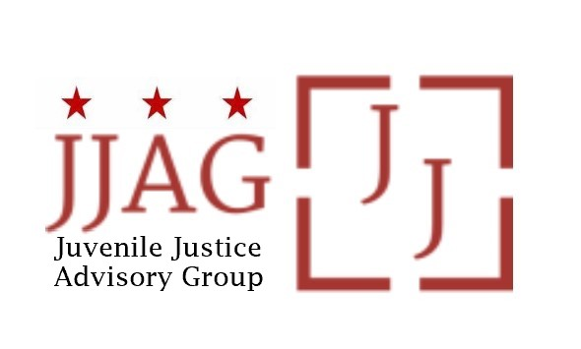

**Juvenile Justice Advisory Group (JJAG)**

**Meeting Agenda**

Tuesday, November 14, 2023

4:30pm - 6:00pm

Virtual Link: <https://dcnet.webex.com/dcnet/j.php?MTID=m6a9b72b75ebe15db2e31f6e078226ecd>

|  |  |  |
| --- | --- | --- |
| Welcome | Welcome, Introductions and Check-In *(Laura Furr, Chair)* | 10 mins |
| JJAG Business | JJAG Business Update (*Melissa Milchman, JJ Specialist*)   * MOTA reappointments discussion | 20 mins |
| R/ED and  Compliance Monitor Update | *(Toni Lemons, R/ED Coordinator, and Rondell Jordan, Open City Advocates)*   * Sharing Key Takeaways from the CJJ R/ED Conference * Notes on Compliance Monitoring, including of Curfew Pilot | 15 mins |
| Announcements and Updates | Opportunity for Members to Share News, Events, or Calls for Partnership   * Video Contest at OAG *(Dave Rosenthal, OAG)* * *YLA recent and upcoming activities* | 20 mins |
| Follow Up  Discussion | Follow up from CJCC Data Presentation: Improving Service Coordination and Utilization for Pre-trial Youth in the Community (*Laura Furr, Chair*)   * How can agencies increase warm hand-offs of youth and families between agencies and services? * What are ways to increase utilization by youth? * What are ways to increase utilization by adult caregivers, especially without power to force utilization? | 25 mins |
| Adjourn |  |  |

*This meeting is governed by the Open Meetings Act. Please address any questions or complaints arising under this meeting to the Office of Open Government at*[*opengovoffice@dc.gov*](mailto:opengovoffice@dc.gov).