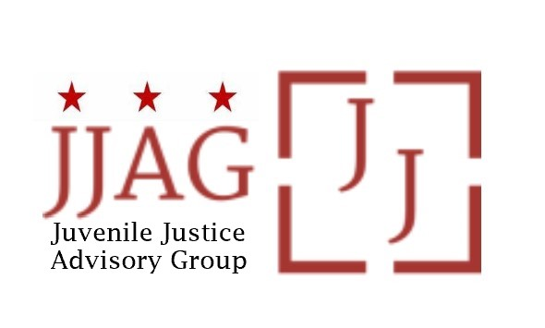

Juvenile Justice Advisory Group (JJAG)
Meeting Agenda
Tuesday, June 6, 2023
4:30pm - 6:00pm
Welcome | Welcome, Introductions and Check-In (Laura Furr, Co-Chair) | 10 mins
JJAG Business | JJAG Business Update and Action (Melissa Milchman, JJ Specialist and Toni Lemons, R/ED Coordinator)  - CJJ Conference Update and Kudos  - Grant Application Status  - Update on proposed legislation with potential impact to racial and ethnic disparities  - Discussion of next steps (Laura Furr, Co-Chair) | 15 mins
Update on Prior JJAG Actions | Update on Transmittal of JJAG Reports and Resolutions to Mayor’s Office (OVSJG Director Jennifer Porter)  - Update on transmittal of JJAG outputs and response from the office of the Mayor/Deputy Mayor for Public Safety and Justice  - Discussion of next steps (Laura Furr, Co-Chair) | 10 mins
2LGBTQIA+ Youth and Juvenile Justice | Presentation and Discussion: Policies and Services to Support 2LGBTQIA+ Youth in Local Systems and the Community (Laura Furr, Co-Chair) | 50 mins
Updates and Announcements | Invitation to members, advisors, and partners to share updates, opportunities for collaboration, news, etc. | 5 mins
Adjourn

This meeting is governed by the Open Meetings Act. Please address any questions or complaints arising under this meeting to the Office of Open Government at opengovoffice@dc.gov.

