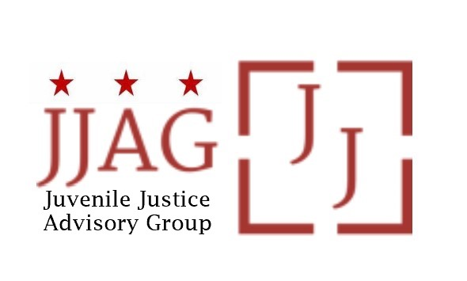

Juvenile Justice Advisory Group (JJAG)
Meeting Agenda
Tuesday, April 2, 2024
4:30pm - 6:00pm
In person: 441 4th Street NW, Suite 1117
Virtual: https://dcnet.webex.com/dcnet/j.php?MTID=m403fbd92d8933b8c4da3a701bbcc0b30

Welcome | Welcome, Introductions and Check-In (Laura Furr) | 20 mins
JJAG Business | JJAG Business Update (Laura Furr)  - Swearing in of returning and new members  - Retreat reminder and check in  - Welcome new Compliance Monitor/R.E.D. Coordinator | 10 mins
YLA Presentation and Discussion | Presentation of Data Collected during YLA Youth Outreach Events and Discussion (YLA Members) | 25 mins
DYRS Providers Presentation and Discussion | Presentation and Discussion of System and Collaboration Challenges Identified by DYRS Providers (Bruce Wright, DYRS) | 25 mins
Updates and Announcements | JJAG Members and Advisors share updates or announcements and highlight upcoming opportunities for collaboration | 10 mins
Adjourn

"This meeting is governed by the Open Meetings Act. Please address any questions or complaints arising under this meeting to the Office of Open Government at opengovoffice@dc.gov."

