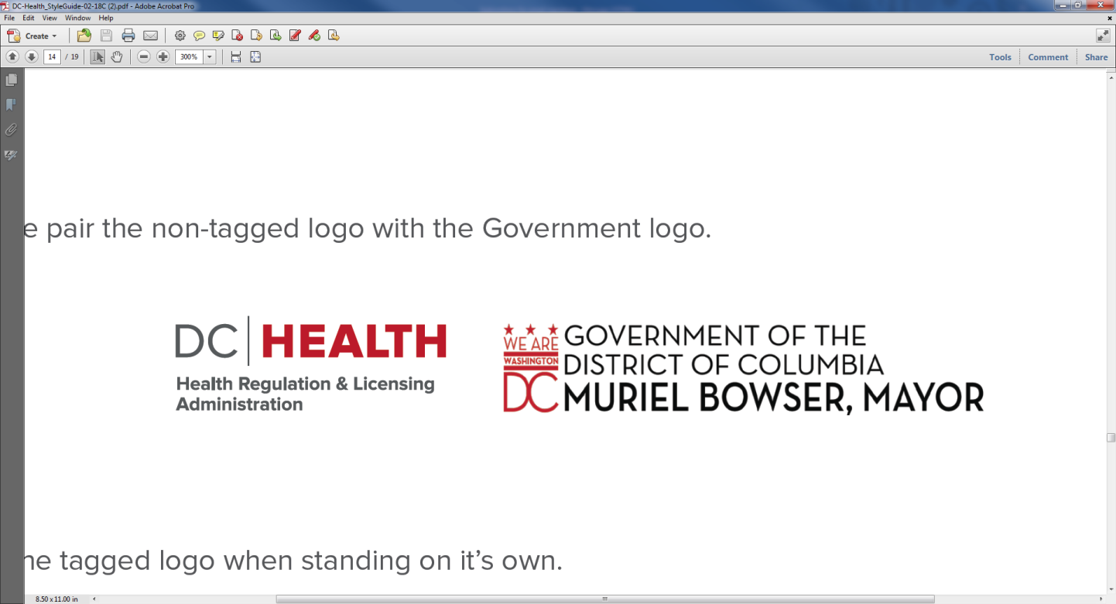**9**

**2201 Shannon Place, SE**

**2nd Floor**

**Washington, DC 20020**

**February 6, 2025**

**9:31 AM – 9:54 AM**

**Open Session Minutes**

**(Webex Meeting)**

**Board of Pharmacy Mission Statement:**

“To protect and improve the public health through the efficient and effective regulation of the practice of Pharmacy and Pharmaceutical Detailing; through the licensure of Pharmacists, Pharmaceutical Detailers, Pharmacy Interns, and Pharmacy Technicians.”

**CALL TO ORDER**: 9:31 AM

**PRESIDING**: Dr. Allison Hill, Pharm.D. R.PH Chairperson

**BOARD MEMBERSHIP/ATTENDANCE**:

|  |  |  |
| --- | --- | --- |
| BOARD MEMBERS: |  |  |
|  | Dr. Allison Hill, Pharm.D. R.PH Chairperson | Present |
|  | Dr. Benjamin MILES, PHARM.D. R.PH | Present |
|  | Dr. Ashlee Bow, Pharm.D. R.PH | Absent |
|  | Dr. Jamilia Jorden, Pharm.D. R.PH | Present |
|  | Mr. Rodrick McGill, Esq. Consumer Member | Absent |
|  |  |  |
| STAFF: | Dr. Reginal Bellamy, PHARM.D. R.PH Supervisory Pharmacist | Present |
|  | Karin Barron, Health Licensing Specialist | Absent |
|  | Luanne Greenaway, Program Specialist | Present |
|  | Countee Gilliam, Board Investigator | Absent |
|  |  |  |
| LEGAL STAFF: | Carla Williams, Senior Assistant General Counsel | Present |
|  |  |  |
|  |  |  |
| VISITORS: | Dr. Karla Evans, MedStar |  |
|  | Vinhi Ghandi, Medstar |  |
|  | Dr. Carolyn Rachel-Price, Washington DC Pharmacy Association |  |
|  | Christinia Antoun, Roman Health Ventures, Inc. |  |
|  | CJ Franklin, Howard University College of Pharmacy |  |
|  | Gail Elliott, Kaiser Permanente |  |
|  | Grace Sesi, CVS Health |  |
|  | Joan Lelma, BEGA |  |
|  | Joanne Dial, Kaiser Permanente |  |
|  | Juan Gabriel Medrano, Washington DC Pharmacy Association |  |
|  | Marci Baloga, Safeway Pharmacy |  |
|  | Scott Tomerlin, Walgreens Pharmacy |  |
|  | Susan DelMonico, Genoa Healthcare |  |
|  | Kim Jennings |  |
|  | Danielle DiCiolla |  |
|  | Nicole Daniels |  |
|  |  |  |
|  |  |  |
|  |  |  |
|  |  |  |
|  |  |  |
|  |  |  |
|  |  |  |
|  |  |  |

**Open Session Agenda**

**Quorum**: Yes

|  |  |  |
| --- | --- | --- |
| **Introduction:** |  |  |
| **0206-O-01** | **Approval of the Open Session Meeting Minutes for:**   * December 5,2024 Open Session Meeting Minutes   **Motion**: Board Member, Dr. Benjamin Miles moves the Board to approve the December 5,2024 open session meeting minutes.  **Seconded by**: Board Chair, Dr. Allison Hill.  Dr. Benjamin Miles: Votes in favor of the motion.  Dr. Ashlee Bow: Absent.  Mr. Roderick McGill: Absent.  Dr. Jamilia Jordan: Abstains.  Dr. Allison Hill: Votes in favor of the motion.  **Abstention:** Dr. Jamilia Jorden.  **Motion carried.**   * January 2, 2025 Open Session Meeting Minutes   **Motion**: Board Member, Dr. Benjamin Miles moves the Board to approve the January 2, 2025 open session meeting minutes.  **Seconded by**: Board Chair, Dr. Allison Hill.  Dr. Benjamin Miles: Votes in favor of the motion.  Dr. Ashlee Bow: Absent.  Mr. Roderick McGill: Absent.  Dr. Jamilia Jordan: Abstains.  Dr. Allison Hill: Votes in favor of the motion.  **Abstention:** Dr. Jamilia Jorden.  **Motion carried.** |  |
| **Consent Agenda** | **None** |  |
| **Chairperson Report** | **None** | Dr. Allison Hill |
| **Office of Government Relations (OGR) Report Updates** | **New Council Period**:   * Council Period 26 started on January 2, 2025. * Committee assignments were released as part of [PR26-0002](https://lims.dccouncil.gov/Legislation/PR26-0002). In this resolution, Councilmember Henderson was reappointed as Chairperson of the Committee on Health with Councilmembers Allen, Felder, Parker, and Nadeau as the other members.     **Performance Oversight**:   * The Council will conduct its FY24 Performance Oversight process over the coming months. * DC Health will take this opportunity to share developments, which occurred in the last fiscal year, including those pertaining to health professional licensing.   + The Board of Pharmacy, as well as the Boards of Psychology, Medicine, and Dentistry will testify on March 5, 2025. * DC Health's Hearing date for public witnesses is February 24, 2025. Government witnesses will be heard on February 26, 2025. | Ms. Kera Johnson |
| **Executive Director Report** | **Statistical Report on Pharmacy Professionals in the District of Columbia**   |  |  | | --- | --- | |  |  | | **PHARMACEUTICAL DETAILERS** | **768** | | **PHARMACISTS** | **2,343** | | **PHARMACY INTERNS** | **334** | | **PHARMACY TECHNICIANS** | **1,395** | | **PHARMACY TECHNICIAN TRAINEES** | **144** | | **PHARMACISTS WITH VAC AUTHORITY** | **890** | | **PHARMACY TECHNICIAN TRAINING PROGRAMS** | **14** | |  |  |   **Prescription Drug Monitoring Program Updates**   * None   **DCRx (DC Center for Rational Prescribing)**   * None   **Pharmacists and Pharmacy Technicians: Upcoming Renewal**   * The licensure renewal cycle for pharmacist and pharmacy technicians will end on **February 28, 2025**. * The expiration date of licenses has changed. All licenses are now set to expire at the end of the licensee’s birth month, in an odd or even-numbered year according to the licensee’s birth year, ensuring that all licenses will not exceed three years (from the end of the current renewal cycle – i.e. licensure expiration dates will not exceed **February 29,** **2028**). * **Question by Dr. Karla Evans: *On practitioners whose birth year is an even-numbered year and will, therefore, renew their licensees [in 2026], will there be [adjustments resulting in] prorated CEs or licensure renewal [fees] in 2026?***     **Response by Dr. Bellamy:** The Board of Pharmacy currently has no information regarding [adjustments]. There are caveats for licensees with birth months of January and February, which allows licensure expiration in [January and February of] 2028. Therefore, no licensee will renew his/her license in less than a year or after three years of licensure, for the current licensure renewal cycle.   * **Question by Dr. Jamilia Jordan: *The new licensure renewal cycle has been voted on in the past and will go into effect?***   **Response by Dr. Bellamy**: Yes.  **Board Counsel, Ms. Williams adds**: To clarify, this matter was not voted on, or the Board of Pharmacy’s decision. It was a decision made by DC Health for all health occupation licenses. | Dr. Reginal Bellamy on behalf of Dr. Justin Ortique |
| **Senior Assistant General Counsel Report** |  |  |
| **0206-O-02** | **None** | Ms. Carla Williams |
| **Subcommittee Reports** |  |  |
| **0206-O-03** | **Legislative and Regulatory Subcommittee Report**  **None** |  |
| **0206-O-04** | **Communications Subcommittee Report**  **None** | Dr. Ashlee Bow |
| **Pharmacy Technician Task Force** | **None** |  |
| **NABP E-Newsletters** | **January 30, 2025**  **Pharmacists Ranked Fourth Most Trusted Profession in Gallup’s 2024 Survey**  ISMP Safety Briefs: Inhalation Medication Entered Incorrectly Causes Error  **SAMHSA Outlines Guidelines for Overseeing Programs for Opioid Treatment**  **LAPPA Seeks to Expand Mental Health and SUD Treatment in Model Law**  **CDC Unveils Collaborative Plan to Address Health Risks Across People, Animals, and the Environment**  **January 22, 2025**  **NABP Featured in Advancing Technology in Pharmacy Regulation to Keep Patients Safe Documentary**  **Partnership for DSCSA Governance and FDA Announce Three Town Halls on Implementation Progress.**  **California State Board of Pharmacy Issues Waivers to Ensure Continued Medication Access During State of Emergency.**  **DEA Issues Three New Rules About Prescribing Medications via Telemedicine.**  **CDC Reports High Levels of Respiratory Illness Activity Across US.**  **HHS Let’s Get Real’ Campaign Encourages the ‘Act, Recommend, Motivate’ Approach for Health Care Providers**  **Note to the Public: To receive weekly updates from NABP, please sign up by using the following link:** [**https://nabp.pharmacy/newsroom/news/**](https://nabp.pharmacy/newsroom/news/)**.** | Dr. Allison Hill |
| **Comments from the Public** | * **Question by Dr. Nguyen: *For licensees born in the month of March [of an even-numbered year], the licensure renewal is in one year. Will the Board prorate the continuing education [requirement] and licensure renewal fee for next year?***   **Response by Dr. Bellamy**: No provisions have been made to prorate the continuing education requirements and licensure fee regarding the new licensure expiration dates. This is a decision from DC Health, not the Board of Pharmacy. If updates are forthcoming, the Board will inform the pharmacy community.   * **Question by Dr. Gandhi: *I have two questions concerning covered substances: How does the Board want us to handle these medications (i.e. procurement, handling and dispensing of the covered substances?) Will the Board of Pharmacy monitor Medstar for these medications when it inspects [the facility?].***   **Response by Dr. Bellamy:** Please submit your questions to me, via email, at reginal.bellamy@dc.gov and I will respond.   * **Dr. Gandhi** **continues**: ***Regarding discharge medication prescriptions,*** ***should be handled for those – is this a question [to be submitted] by email?***   **Response by Dr. Bellamy:** Yes, to me.   * **Question by Dr. Karla Evans: *Are there any updates on the proposed regulations on work conditions?***   **Response by Board Counsel, Ms. Williams:** The regulations regarding working conditions are under the purview of the Pharmaceutical Control Division and DC Health; not the Board of Pharmacy. Such information is shared at the Board meetings to ensure that all stakeholders are aware of [updates]. The comment period for these regulations ended on December 24, 2024 and the Board is now reviewing the comments. When the Board has further information, it will be shared during an open session Board meeting.   * **Question by Dr. Karla Evans: with the regulations regarding surveillance cameras for automated dispensing machines, who should be contacted regarding disconnection of the cameras for a period of time? While the regulations state that it should be reported, it is not clear who should receive the report.**   **Response by Board Counsel, Ms. Williams:** In the District of Columbia, the regulation of pharmacies is split between the Board of Pharmacy and DC Health’s Pharmaceutical Control Division. Pharmacy practice is under the jurisdiction of the Board of Pharmacy while the operation of the pharmacy is under the purview of DC Health’s Pharmaceutical Control Division. The point of contact is Dr. Justin Ortique, who is currently out of the office. In the interim, you may contact Dr. Reginal Bellamy at reginal.bellamy@dc.gov.   * **Remark by Dr. Carolyn Rachel-Price: The following is the update on the activity of the *Washington, DC Pharmacy Association*:** * In January, 2025 the *Washington, DC Pharmacy Association* held a summit with independent pharmacy providers in the District of Columbia as they are concerned about their viability regarding Pharmacy Benefit Manager (PBM) reform. Many independent pharmacies are struggling due to the Federal Government’s reforms. Summarily, the pharmacies are not receiving payment because of the reform, and the three largest PBMs have seen a $7.3 billion-dollar gain as funds are channeled to pharmacies owned by these PBMs instead of appropriate payment to independent pharmacy providers. Consequently, these pharmacies are concerned about short-term sustainability. * The *Washington, DC Pharmacy Association* will attend the District’s meeting on February 12, 2025 in support of independent pharmacy providers. In the past ten (10) years, thirty-five (35) chain and independent pharmacies have closed. * **Question by Dr. Karla Evans:** ***As we explore new ways to perform pharmacist duties – in-house and in hospital pharmacy as well, as having clinicians focus on clinical surveillance that really impacts our patients – I would like clarification on the language concerning subcontracted services for tele-pharmacy. Also, what is the applicability to a health system that would hire their own employees and consider building a tele-pharmacy service within their institution? Would this [model] fall under subcontracted services for tele-pharmacy, or would institutional pharmacy employees who provide tele-pharmacy services be exempt from these regulations?***     **Response by Board Counsel, Ms. Williams:** This matter falls under the [jurisdiction] of the Pharmaceutical Control Division and should be addressed to Dr. Bellamy, via email, for a response. |  |
| **Motion to Adjourn the Open Session** | **Board member, Dr. Benjamin Miles,** **moves the Board as follows:**  “Madam Chair, I move that the Board close the Open Public session portion of the meeting and move into the Closed Executive Session portion of the meeting pursuant to D.C. Official Code § 2-575(b) for the following purposes: to discuss disciplinary matters pursuant to § 2-575(b)(9); to seek the advice of counsel to the board, to preserve the attorney-client privilege, or to approve settlement agreements pursuant to § 2-575(b)(4); and to plan, discuss, or hear reports concerning ongoing or planned investigations pursuant to § 2-575(b)(14).”  **Seconded by**: Board Member, Dr Jamilia Jordan.  **Roll Call Vote:**  Dr. Benjamin Miles: Votes in favor of the motion.  Dr. Ashlee Bow: Absent.  Mr. Roderick McGill: Absent.  Dr. Jamilia Jordan: Votes in favor of the motion.  Dr. Allison Hill: Votes in favor of the motion.  **Abstentions: None.**  **Motion Carried.** |  |

This concludes the Public Open Session of the meeting. The Board will now move into the Closed Executive Session portion of the meeting pursuant to D.C. Official Code § 2-575(b) for the reasons set forth in the motion.

**Open Session Meeting Adjourned at 9:54 AM.**

**This meeting is governed by the Open Meetings Act. Please address any questions or complaints arising under this meeting to the Office of Open Government at opengovoffice@dc.gov.**