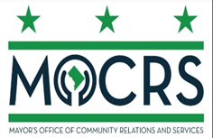

District Of Columbia Mayor’s Interfaith Council
Notice Of Public Meeting
Thursday, April 23, 2026
6:00PM-8:00PM

Location: 899 North Capitol Street NE, Room 1007/1008

AGENDA
Call to Order
Remarks- Rev. Karen Curry, Chairwoman of the Mayor’s Interfaith Council
Introductions
Welcome- Charity Beam (Faith Liaison, Wards 1-4) and Rev. Ryan Lindsay Arrendell (Faith Liaison, Wards 5-8)
Overview of Council & Purpose - Charity Beam (Faith Liaison, Wards 1-4) and Rev. Ryan Lindsay Arrendell (Faith Liaison, Wards 5-8)
Open Forum/Discussion
Concluding Remarks
Adjournment

This meeting is governed by the Open Meetings Act. Please address any questions or complaints arising under the meeting to the Office of Open Government at opengovoffice@dc.gov. All agendas, whether draft or final, must include the statement. The statement is required pursuant to 3 DCMR §10409.2.

