COMMISSION ON OUT OF SCHOOL TIME GRANTS AND YOUTH OUTCOMES
STRATEGIC PLAN
Adopted [INSERT DATE]
About Learn24
Learn24 is a network of afterschool and summer opportunities supported by the Bowser Administration to ensure children and youth in the District have access to quality educational and enrichment activities beyond the school day.

A decade of research indicates that children and youth who regularly participate in quality afterschool and summer programs benefit in terms of their academic performance, social and emotional learning, and health and wellness. In addition, youth who participate in Out of School Time (OST) programs have improved school attendance; higher graduation rates; lower dropout rates; stronger academic performance and improved positive behaviors and work habits.

Learn24 supports access to and cultivation of high quality OST programs by:
- Building the skills for adults who work with children and youth in OST programs through workshops and conferences organized by The Institute of Youth Development.
- Working directly with OST program leaders and staff through observation, assessment and coaching to improve the program design and implementation.
- Communicating the importance of quality to key stakeholders to increase accountability across the network of OST providers.
- Measuring and reporting on outcomes for children and youth across the network.

The Office of Out of School Time Grants and Youth Outcomes, located in the Office of the Deputy Mayor for Education and informed by the Mayor’s Commission on Out of School Time Grants and Youth Outcomes, leads the Learn24 network.

Vision
Children and youth across the District have equitable access to high quality out-of-school-time programs.

Quality OST programs support children and youth thrive by developing skills, attitudes and knowledge to succeed in life toward self-sufficiency as engaged citizens.

Purpose
Learn24 supports equitable access to high-quality, out-of-school-time programs for District of Columbia youth through coordination among government agencies, targeted grant-making, data collection and evaluation, and the provision of training, capacity building and technical assistance to OST providers.

Key Finding OST Needs Assessment
- Afterschool capacity
  - 33,400 children and youth attend regular afterschool programming in D.C.
  - Includes 28,700 children in pre-K to 8th grade and 4,700 youth in grades 9-12
  - Main providers are schools and community-based organizations (CBOs)
- Summer school capacity
  - 15,000 children and youth from pre-K3 to 12th grade participate in summer programs in D.C.
  - Includes 4,700 entering pre-K3 to 8th grade, and 10,800 in grades 9 through 12
  - Not counting MBSYEP participants, the number of summer program participants in grades 9 through 12 was less than 2,800)

Estimated Gap in OST program Capacity under four policy goals
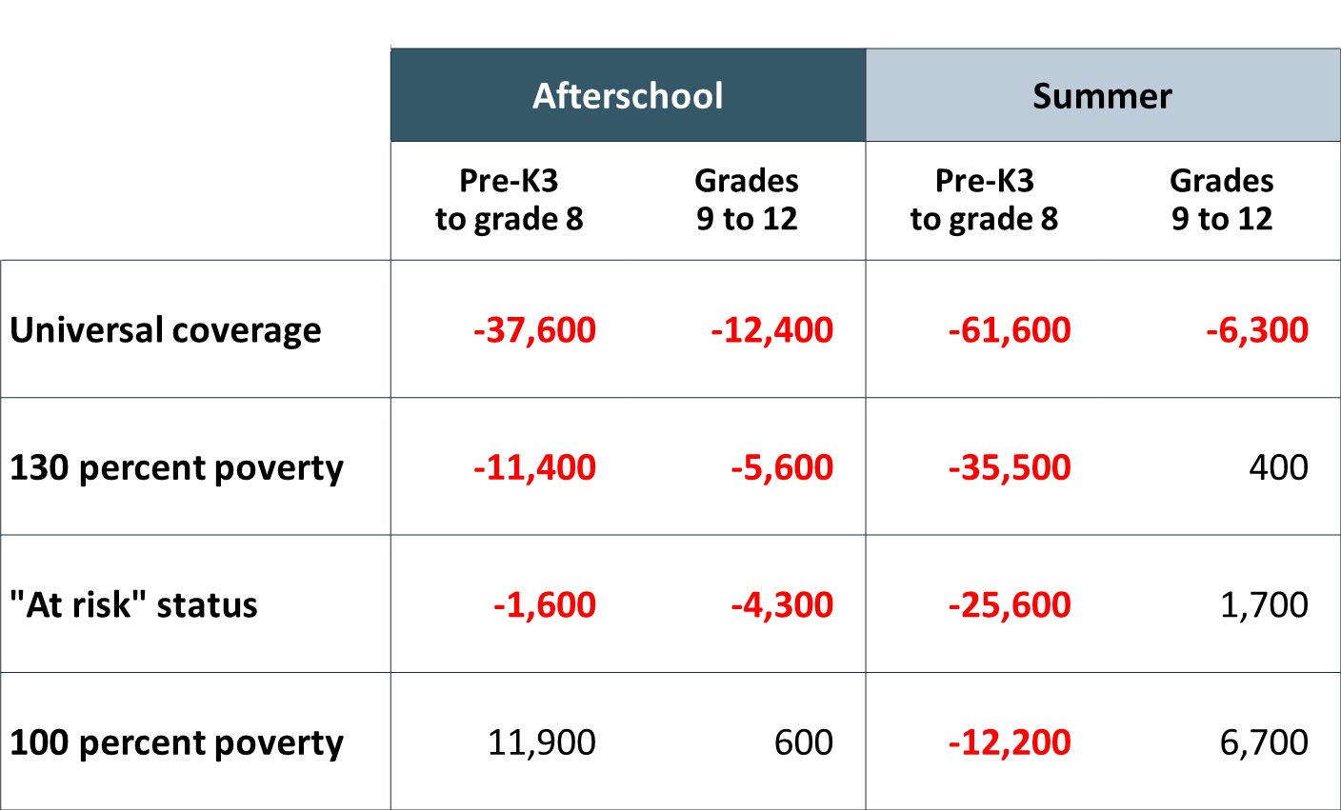

Values [to be discussed]
- Equity: Access to opportunities for youth to succeed
- Collective Action: there is a mutual dependence across the system and stakeholders that we value action as a whole but recognize the work of the one
- Commitment to Learning: a vibrant ecosystem requires a commitment to learning, understanding and sharing best practices
- Youth Voice: youth to be listened and encouraged to lead the work

Goals
- Target grant-making to increase equitable access to quality out-of-school-time programming;
- Encourage and support coordination among government agencies;
- Improve program quality through assessment, training, capacity building and technical assistance to OST providers; and
- Utilize data to measure impact and support evaluation of the network.

Theory of Change
System: provides citywide critical infrastructure support, guidance and communication
Youth: successfully transition from childhood, to adolescent to adulthood
Program: high quality programs and experience retain youth and provide the necessary dosage for impact
Organization: Strong management practices offer programmatic infrastructure and ability for programs to scale

Strategic Priorities [to be discussed]
- Equity
- Children and Youth Thrive
- Coordination

System Level
Equity
Priority | Tactics | Metrics
Funding/Grantmaking
Geography, Race, gender, age, income, life experiences
Children and Youth Thrive
Priority | Tactics | Metrics
Database to measure outcomes, youth enrollment, longitudinal impacts
Coordination
Priority | Tactics | Metrics
Cross agency
(DCPS, DOES,
Funding (local, federal and private)
Existing Initiatives (Attendance, Transit, health, trauma, violence)
Current infrastructure
Citywide Goals
Transportation
OST Reporting
Schools and Nonprofits
Meeting Basic need (food, housing, etc.)

Organization
Equity
Priority | Tactics | Metrics
Support small grassroots organizations
Children and Youth Thrive
Priority | Tactics | Metrics
Capacity Building:
Grant writing support; grow and develop new orgs in areas of need; scaffold based on org need
Focus funding on organizations that meet basic standards
Parent engagement; trauma support; learning at home
Coordination
Priority | Tactics | Metrics
Content expertise and Coordinating Entities
Shared resources/staff/synergy

Program
Equity
Priority | Tactics | Metrics
Children and Youth Thrive
Priority | Tactics | Metrics
Quality – Define and Improve
(assess, plan, improve, repeat)
Professional Development and Training
Data collection
Scaling Programs
Measuring Outcomes/Evaluation
Broad programming options
Year round planning and programming
Evidence Based Programming
Coordination
Increase Hours

Youth
Equity
Priority | Tactics | Metrics
Youth Forum
Undoing racism
Children and Youth Thrive
Priority | Tactics | Metrics
Skills Framework by age; special population
Measuring Youth Outcome (Health, academic, attendance, relationships, prepare for future/economy needs, workforce development)
separate youth programs from SYEP
New experiences/paths
Maintaining Gains (k-12)
Coordination
Priority | Tactics | Metrics
Youth Forum

Other:
- SMART goals. Big, Audacious Goals
- Where does youth voice belong, engage with the system? How can youth voice be authentic and make the most impact on the systems?
- Simple, Clear easy to understand final document
- Public Input

