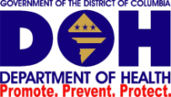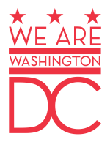**Government of the District of Columbia**

**Department of Health**

**Health Regulation & Licensing Administration  
Board of Pharmacy**

**PUBLIC HEARING On Proposed Rulemaking**

**Regarding Collaborative Practice Agreements**

**Between Physicians and Pharmacists**

**THURSDAY, MAY 5, 2016**

**09:00 A.M-11:00AM., ROOM 216,**

**899 NORTH CAPITOL STREET, NE 2ND FLOOR  
WASHINGTON, D.C. 20002**

**WITNESS LIST**

1. Vicki Basalyga, Pharm.D., BCPS Director, Section of Clinical Specialists

Pharmacy Practice Sections

1. David W. Wilmot Partner

Harmon & Wilmot, LLP

1. Katherine Pham, Pharm.D. Clinical Pharmacist

Children’s National Health Systems

1. Benjamin Hammer, Pharm.D. Clinical Pharmacist

Children’s Nationals Health Systems

1. Mark D. Johnson Sir. Director, Pharmacy Regulatory Affairs
2. Bill Irvin, R.Ph. Director. Pharmacy Regulatory Affairs