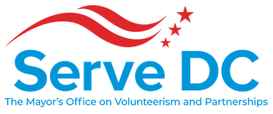
DC Commission on National and Community Service
2000 14th Street NW | Suite 101 | Washington, DC 20009 | 9.26.19 | 6:00 PM
Please join my meeting from your computer, tablet or smartphone.
https://global.gotomeeting.com/join/523680101
You can also dial in using your phone.
United States: +1 (872) 240-3212 Access Code: 523-680-101
New to GoToMeeting? Get the app now and be ready when your first meeting starts:
https://global.gotomeeting.com/install/523680101
AGENDA

- Call to Order - Brandon Andrews, Chair
- Roll Call - Lavita Anthony, Executive Assistant
- Approval of the Minutes
- Chair’s Opening Remarks - Brandon Andrews, Chair
- Director’s Report – Ayris T. Scales, Chief Service Officer
  - Operations
  - Events
  - FY19 Recap & Closeout
  - New Partnership Opportunities/initiatives – Service Year Alliance

- Program Updates
  - AmeriCorps FY19/20 Grant Application Timeline- Jenny Kessler, National Service Officer
  - CERTCON 2019 – Anthony Stevens, Director Volunteer & Donations Management
  - Opportunities to Get Involved & Serve– Tyler Brown, Communications Specialist

- Commissioner Updates
  - Status of Commissioner Appointments, Ayris T. Scales, Chief Service Officer
  - Subcommittees, Brandon Andrews, Chair
  - Establishing a Serve DC 20th Anniversary Ad hoc Committee, Ayris T. Scales, Chief Service Officer

- Announcements (Commissioners Roundtable)
- Set Next Meeting Date - Brandon Andrews, Chair
- Adjourn

