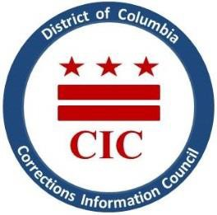
CIC | DC Corrections Information Council

CIC Quarterly Board Meeting
Date: Thursday, March 12, 2026
Location: 1400 I St. NW, Suite 400 (Conference Room) Washington, DC 20005
Time: 6-7:30pm

Welcoming

- Roll Call
- Previous meeting minutes review
- Executive Director report
- BOP updates
- DOC updates
- Closing Remarks

This meeting is governed by the Open Meetings Act. Please address any questions or complaints arising under this meeting to the Office of Open Government at opengovoffice@dc.gov.

