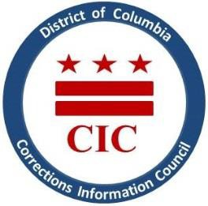
CIC | DC Corrections Information Council

CIC Board Meeting
Thursday, July 20, 2023
6:00 PM
Location: Marion S. Barry, Jr. Building. 441 4th St NW, Room 1107 Washington, DC 20001

Welcoming
- Roll Call
- April meeting minutes review
- Executive Director report
- BOP updates
- DOC updates
- Current & Upcoming projects (thematic reports and information sheets)
- Q&A and Closing Remarks
- Closed Portion with Executive Director and CIC Board to discuss personnel matters,
pursuant to DC Code §2-575(B)(10)

This meeting is governed by the Open Meetings Act. Please address any questions or complaints arising under this meeting to the Office of Open Government at opengovoffice@dc.gov

