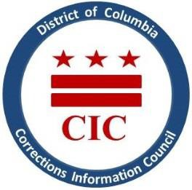
CIC | DC Corrections Information Council

CIC Board Meeting
Wednesday, April 26, 2023
6:00 PM
Location: MLK Library. 901 G St NW, Washington, DC 20001

Welcoming

- Roll Call
- January meeting minutes review
- Executive Director report
- New hires/staffing updates
- BOP updates- FY23 inspections
- DOC updates/St. Elizabeth’s transfers
- Current & Upcoming projects (thematic reports and information sheets)
- Community requested information (Q & A)
- Closing Remarks

