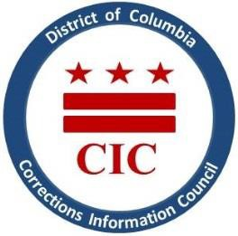
CIC | DC Corrections Information Council

CIC January Board Meeting
Wednesday January 25, 2023 11:00 AM
Join Teams Meeting:
http://bit.ly/3GTm2PD

Welcoming

- Roll Call
- October meeting minutes review
- Executive Director report
- New hires/staffing updates
- BOP updates- FY23 inspections
- DOC updates/St. Elizabeth’s transfers
- Closing Remarks

This meeting is governed by the Open Meetings Act. Please address any questions or complaints arising under this meeting to the Office of Open Government at opengovoffice@dc.gov.

