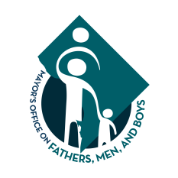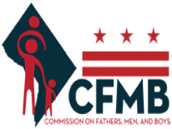

**CFMB 2020- Q2 PUBLIC MEETING AGENDA**

**MEETING INFORMATION**

**Objective:** The purpose of this meeting is to discuss FY2020 strategic initiatives and potential policy recommendations.

|  |  |
| --- | --- |
| **Date:** February 19th, 2020 | **Location:** 441 4th Street NW Washington, DC 20002. Rm 1112 |
| **Time:** 6:30pm to 8pm | **Meeting Type:** Public Meeting |
| **Notified By:** MOFMB | **Facilitator:** George Garrow |
| **Confirmed Attendees:** D. Smith, T. Henry, F. Malone, A. Hewitt, G. Garrow, S. Grant, B. Brown, E. Scott  **Unconfirmed Attendees**: V. Johnson, A. Burnett, I. Toldson, | Note Taker: Michael Dodson |

**AGENDA ITEMS**

|  |
| --- |
| Call to Order                                                                                                                   Chair Garrow |
| Commissioner Roll Call                                                                                                     Chair Garrow |
| Review of Previous Meeting Minutes                                                                                 Chair Garrow |
|  |
| Introduction of New Commissioner Ben-James Brown Chair Garrow |
| 2020 Initiatives                                                                                      Director Wallace |
| Ideas for potential legislation                                                                                 Commissioner Discussion |
| Final Remarks                                                                                               Director Wallace |
| Adjournment                                                                                                                     Chair Garrow |