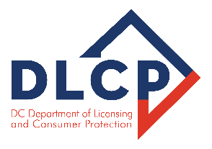

OCCUPATIONAL AND PROFESSIONAL LICENSING DIVISION
D.C. Board of Funeral Directors 1100 4th Street SW, Room E300 Washington, DC 20024

MEETING AGENDA

Thursday, April 2nd, 2026
1:00 PM

- Call to Order – [1 p.m.]

- Roll Call

- Comments from the Public

- Approval of March 5th, 2026 meeting minutes

- Legislative Updates:

- Old Business:

- New Business:

Motion – Executive Session (Closed to the Public) to consult with an attorney pursuant to Official Code § 2-575(b)(4)(A); D.C. Official Code § 2-575(b)(9) to discuss complaints/legal matters, applications, and legal counsel reports.

- Applications
- Complaints
- Additional updates/discussion
- Recommendations
- Adjourn – Next Scheduled Meeting – May 7th, 2026: via Zoom (Virtual)

Zoom Meeting: https://dc-gov.zoom.us/j/85308203416

This meeting is governed by the Open Meetings Act. Please address any questions or complaints arising from this meeting to the Office of Open Government at opengovoffice@dc.gov.

