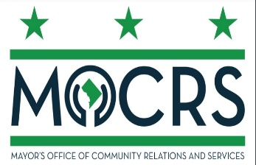

District Of Columbia Commission for Nightlife and Culture
Notice Of Public Meeting
Tuesday November 18, 2025
6:30PM-8:00PM

Location: John A. Wilson Building
1350 Pennsylvania Ave. NW
Room G9

AGENDA

Call to Order
Welcome Remarks- Vinoda Basnayake, Chairman of Commission
Introduction/Roll Call – Mariah Coilton, Business Liaison Wards 5-8
Streatery Program- Ian Maggard, Senior Advisor DDOT
Grants/Funding- Liz Anderson, Director of Great Streets DMPED
ABCA Extended Hours- Sarah Weigner, Community Resource Officer
DCNC Recap – Pat Rivera, Executive Director of DCNC
Announcements/ Open Forum
Office Update- Talib Shakir, Deputy Director of Community Relations
Next Meeting Date: April 2026
Adjournment

This meeting is governed by the Open Meetings Act. Please address any questions or complaints arising under the meeting to the Office of Open Government at opengovoffice@dc.gov. All agendas, whether draft or final, must include the statement. The statement is required pursuant to 3 DCMR §10409.2.

