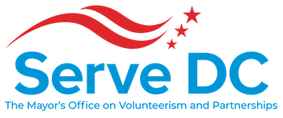

Commissioner’s Meeting

Tuesday, August 25, 2020 | 6:00 PM

**Meeting Link:** <https://dcnet.webex.com/dcnet/j.php?MTID=m844e007206232bb6c3cfdf2b2bc49ddd>

Meeting Number: 160 236 4841

Password: NGpXiCj2Z78

Join By Phone: 1-202-860-2110 United States Toll (Washington D.C.)

Or

1-650-479-3208 Call-in toll number (US/Canada)

Access Code: 160 236 4841

**AGENDA**

* **Call to Order**……………………………………………………………….Brandon Andrews, Chair
* **Roll Call**……………………………………………………………………….LaVita Anthony, Special Assistant
* **Approval of the Minutes**…………………………………………….LaVita Anthony, Special Assistant
* **Chair’s Opening Remarks**…………………………………………….Brandon Andrews, Chair
  + Commissioner Appointments & Vacancies
* **Director’s Report**…………………………………………………………Ayris T. Scales, Chief Service Officer
  + Programs & Operations
  + Thank You and Acknowledgements
* **Presentation: Rebrand Updates**…………………………………….Ayris T. Scales. Chief Service Officer
  + Stakeholder Findings
  + Logo Direction
  + Evolved Messaging
* **Opportunities for Commissioners to Serve & Support**………Alexis Squire, Deputy Director Partnerships & Engagement
  + Commissioner Recruitment
  + Census 2020
  + Ready for Recovery
  + 9/11 Day of Service
  + Spirit of Service Awards
  + State Service Plan
  + Strategic Planning: Youth Engagement and Programming
* **Commissioner Updates and Announcements**……………………………Brandon Andrews, Chair
* **Adjourn**