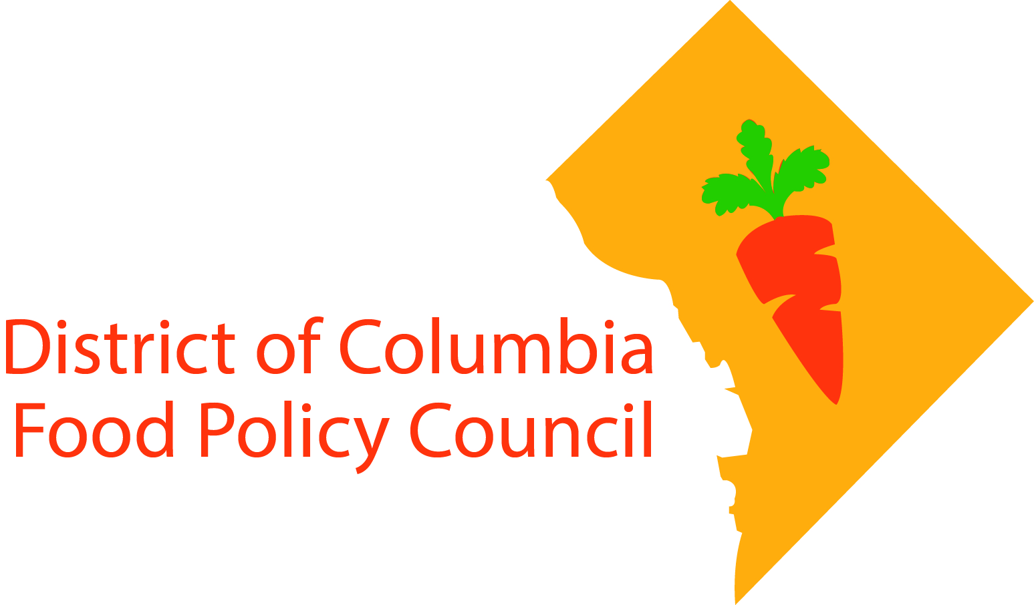

**District of Columbia Food Policy Council**

**August 3, 2016 6:00-8:00pm**

**Agenda**

1. **Welcome & Introductions**
   1. Director, Laine Cidlowski
   2. Chair, Spike Mendelsohn
   3. Food Policy Council Members
   4. Ex Officio DC Agency Members
2. **Background on the Food Policy Council, Director Cidlowski**
   1. History & DC Food Policy
   2. Purpose
   3. Scope of Responsibilities
   4. Operations & Logistics
3. **Food Policy Council Members Present their Priorities**
   1. Question & Answers
4. **Community Input on Priorities - Breakouts**
   1. Working Group Stations
      1. [Local Food Business and Labor Development](https://dcfoodpolicy.org/priorities/working-groups/)
      2. [Food Equity, Access, and Health and Nutrition Education](https://dcfoodpolicy.org/priorities/working-groups/)
      3. Sustainable Food Procurement
      4. [Urban Agriculture and Food System Education](https://dcfoodpolicy.org/priorities/working-groups/)
   2. Big Picture Issues
5. **Next Steps**
   1. Next Public Meeting
   2. Working Group Meetings - September

Can't come to a meeting but still want to get involved? Go to our website - [dcfoodpolicy.org](https://dcfoodpolicy.org/)/  
Follow us on Twitter [@DCFoodPolicy](https://twitter.com/DCFoodPolicy) Like our [Facebook page](https://www.facebook.com/dcfoodpolicycouncil/)