**ADVISORY BOARD ON VETERANS AFFAIRS**

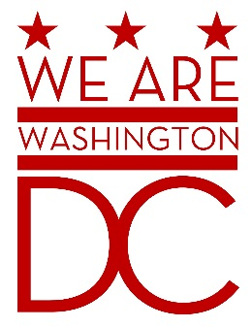

**MEETING AGENDA**

**Tuesday, 6 September 2016**

**441 4th Street NW/One Judiciary Square**

**11th floor, Room 1114**

**Washington DC 20001**

**6:30 – 8:00 p.m.**

1. **Call to Order**
2. **Pledge of Allegiance**
3. **Advisory Board Members Roll Call**
4. **Agenda**
5. **Approval of Minutes**
   1. August minutes sent by email to board members.
6. **Special Guests** 
   1. Coalition to Restore DC Pension Benefit Exclusion
      1. Laura Richards
      2. Sylvester Bush
7. **Director’s Report** (Time reserved for Charon Hines, Director of the Mayor’s Office of Community, or representative of OVA.)
8. **Committee Reports**
   1. Updates to objectives from strategic plan
9. **Old Business** (Chairman)
10. **New Business (**Chairman**)**
11. **Public Comment (Maximum 2 minute per person)**
12. **Upcoming (Events/Meetings/Holidays)**
13. **Adjournment**