ADVISORY BOARD ON VETERANS AFFAIRS
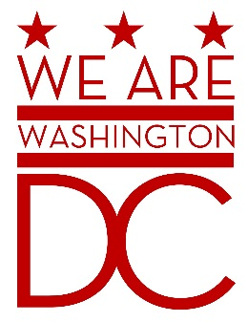

MEETING AGENDA
Tuesday, 1 March 2016

441 4th Street NW
One Judiciary Square – Old Council Chambers
Washington DC 20001
6:30 – 8:00 p.m.

- Call to Order
- Pledge of Allegiance
- Advisory Board Members Roll Call
- Agenda
- Approval of Minutes
  - See http://www.bega-dc.gov/board-commissions-meetings/mayors-advisory-board-veterans-affairs for audio file. (May be delays in posting due to lack of recording system in meeting room.)
- Special Guests
  - None announced
- Director’s Report
- Committee Reports

- Old Business (Chairman)
  - Discussion of By-Laws amendment regarding voice votes
    - At the December meeting, a proposal to amend line 111.7 to read “All votes shall be done by voice Vote. Following the voice vote, any member may call for a roll-call vote. If the call is seconded, a roll call vote will be conducted.”
    - The board discussed proposal in February, but tabled it without voting.
  - Discussion of resolution on the establishment of a Veterans’ Hall of Fame in the District of Columbia (see attached)
    - Mr. Khan introduced this resolution at the February meeting and plans to propose the board approve it at this meeting.
- New Business (Chairman)
  - Discussion of committee reporting (Vice Chair)
- Public Comment (Maximum 2 minute per person)
- Upcoming (Events/Meetings/Holidays)
  - Next board meeting: 4 April 2016, 6:30-8pm. See http://www.bega-dc.gov/board-commission/meetings for agenda
- Adjournment

