ADVISORY BOARD ON VETERANS AFFAIRS
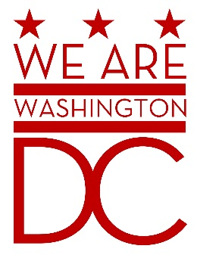
MEETING AGENDA
Tuesday, 5 April 2016
441 4th Street NW
One Judiciary Square – Old Council Chambers
Washington DC 20001
6:30 – 8:00 p.m.

- Call to Order
- Pledge of Allegiance
- Advisory Board Members Roll Call
- Agenda
- Approval of Minutes
  - See http://www.bega-dc.gov/board-commissions-meetings/mayors-advisory-board-veterans-affairs for audio file. (May be delays in posting due to lack of recording system in meeting room.)
- Special Guests
  - Charles W. McCaffrey, MBA, Director, Veterans Business Outreach Center at Community Business Partnership of Springfield, http://www.cbponline.org/
  - Charles Eggleston & Anthony Cancelosi, National Capitol Region, Community Engagement Board
  - Carl E. Brown Jr., Executive Director, DCSBDC Network, https://www.dcsbdc.org/
- Director’s Report
  - #Fightfor15 Raise the Minimum Wage Pledge
  - Budget Hearings
- Committee Reports

- Old Business (Chairman)
- New Business (Chairman)
  - Discussion of committee reporting (Vice Chair)
- Public Comment (Maximum 2 minute per person)
- Upcoming (Events/Meetings/Holidays)
  - Tuesday, April 5: 2016 Mayor’s Day of Recognition for National and Community Service
    - DC Commission on Arts and Humanities Building, 200 I Street, SE, First Floor (Make a right at the Security Desk), Washington, DC 20003
- Adjournment

