Occupational and Professional Licensing

District of Columbia Board of Architecture, Interior Design and Landscape Architecture

March 10, 2023
Administrative Application List

Architects (Endorsement -25)
Nicholas Dreisbach | James Baumgardner | Ho Cheuk Choi
Michael Glassman | Charles Selden | Charles Selden
Ross Brown | Liliia Kolesnyk | Michael Hanson
Osama Iqab | Ana Montano | Lynn Kuckelman
Marta Kazmierska-Skupinska | Matthew Wheeler | Matthew Gifford
Mark Hughes | Keval Thakkar | Matthew Dirksen
Gary Chan | Christopher Kehde | Steven Rowland
John Graham | Kay Townsend | Allan Krueger
William Hoisington

Professional Design Firms (Endorsement - 1)
Skillern Fein Architects PLLC

Landscape Architects (Endorsement -8 )
Michael DeGregorio | Nathan Novak | Stephen Eich
Kathryn Landis | Lori Singleton | Richard Williams
Danielle Schwartz | Adam Greenspan

Interior Design (Exam - 4)
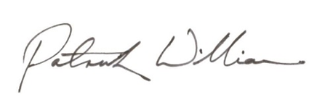  Colletta Conner | Nastaran Rashid Benam | Kelly Brocki
Lisa Haude

________________________________________________
Approved: Patrick Williams, Vice Chairman
for Ronnie McGhee, Chairman

