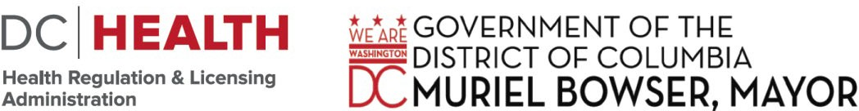

899 NORTH CAPITOL STREET, NE
9
2ND FLOOR WASHINGTON, DC 20002

March 27, 2024

DC Board of Pharmacy Legislative & Regulatory Subcommittee Meeting AGENDA
(WEBEX MEETING)

Board of Pharmacy Mission Statement:
“To protect and improve the public health through the efficient and effective regulation of the practice of Pharmacy and Pharmaceutical Detailing; through the licensure of Pharmacists, Pharmaceutical Detailers, Pharmacy Interns, and Pharmacy Technicians.”

CALL TO ORDER: PRESIDING:
BOARD MEMBERSHIP/ATTENDANCE:
COMMITEE
MEMBERS:
 | MR. ALAN FRIEDMAN, R.PH, VICE CHAIRPERSON
 | DR. BENJAMIN MILES, PHARM.D. R.PH
 | DR. ASHLEE BOW, PHARM.D. R.PH
STAFF: | DR. JUSTIN ORTIQUE, EXECUTIVE DIRECTOR
LEGAL STAFF: | CARLA WILLIAMS, SENIOR ASSISTANT GENERAL COUNSEL
 | Angel Cruz, ASSISTANT GENERAL COUNSEL
VISITORS:

Open Session Agenda

Quorum:

Introduction:
0327-O-01 | Self-administered Hormonal Contraceptive Pamphlet Final Edits
0327-O-02 | Pharmacy Working Conditions
0327-O-03 | Remote Prescription Processing
0327-O-04 | Action Steps/Next Meeting
Comments from the Public

This concludes the Public Open Session of the DC Board of Pharmacy Legislative & Regulatory Subcommittee meeting.

Open Session Meeting Adjourned at _:_

This meeting is governed by the Open Meetings Act. Please address any questions or complaints arising under this meeting to the Office of Open Government at opengovoffice@dc.gov.

